PortSwigger Web Security Academy — Proof of Concept

Prototype Pollution Lab 2

DOM XSS via an alternative prototype pollution vector
Category | Prototype Pollution
Lab | Lab 2
Completed By | Security Researcher
Platform | PortSwigger Web Security Academy

Lab Objective
Exploit an alternative prototype pollution vector to achieve DOM XSS.

Step-by-Step Exploitation
- Open Burp Suite and configure browser proxy.
- Navigate to the lab URL and identify the vulnerable functionality.
- Intercept the relevant HTTP request in Burp Proxy.
- Send the request to Burp Repeater for analysis.
- Craft and inject the appropriate payload into the vulnerable parameter.
- Forward the modified request and observe the response.
- Verify the exploit was successful as shown in the screenshots below.

Screenshots & Evidence
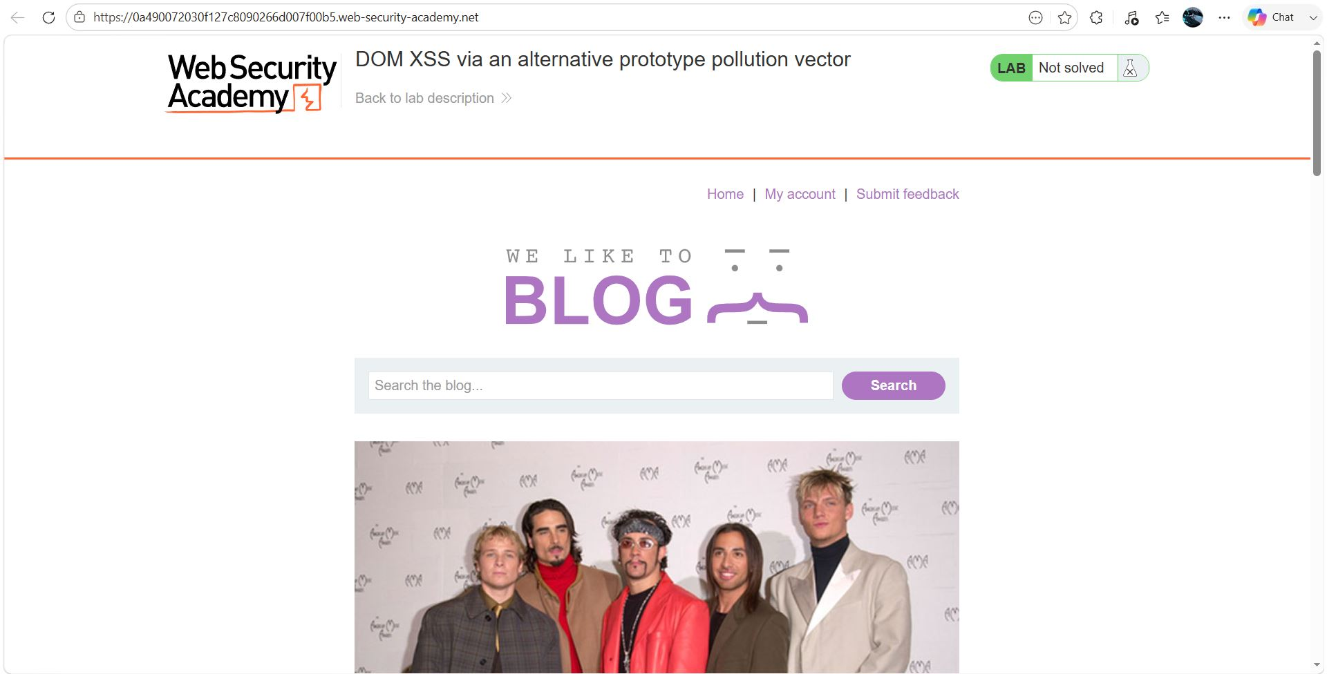
Figure 1: 1
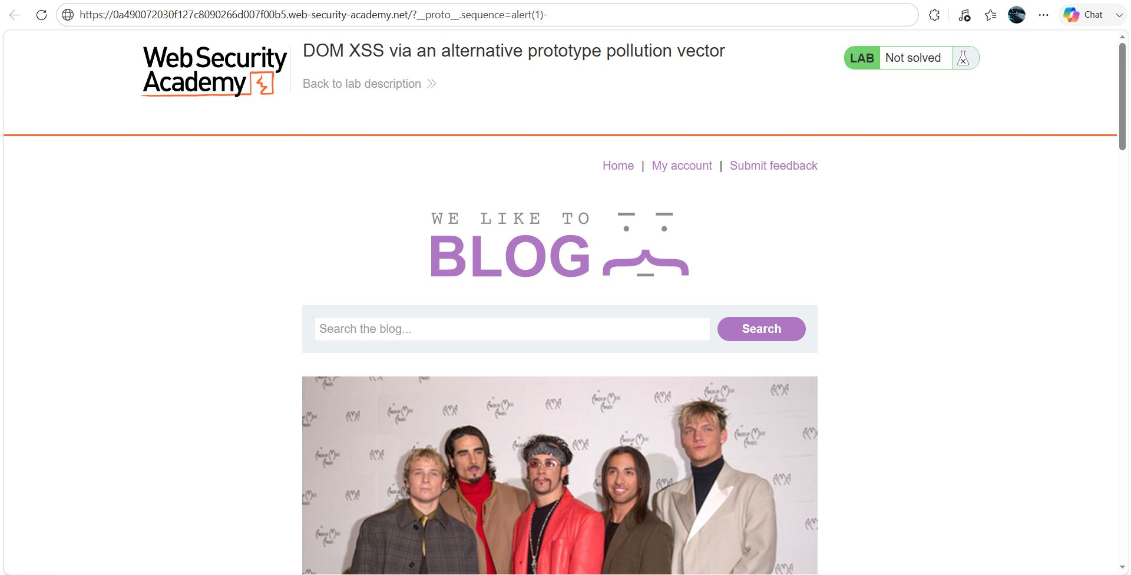
Figure 2: 2
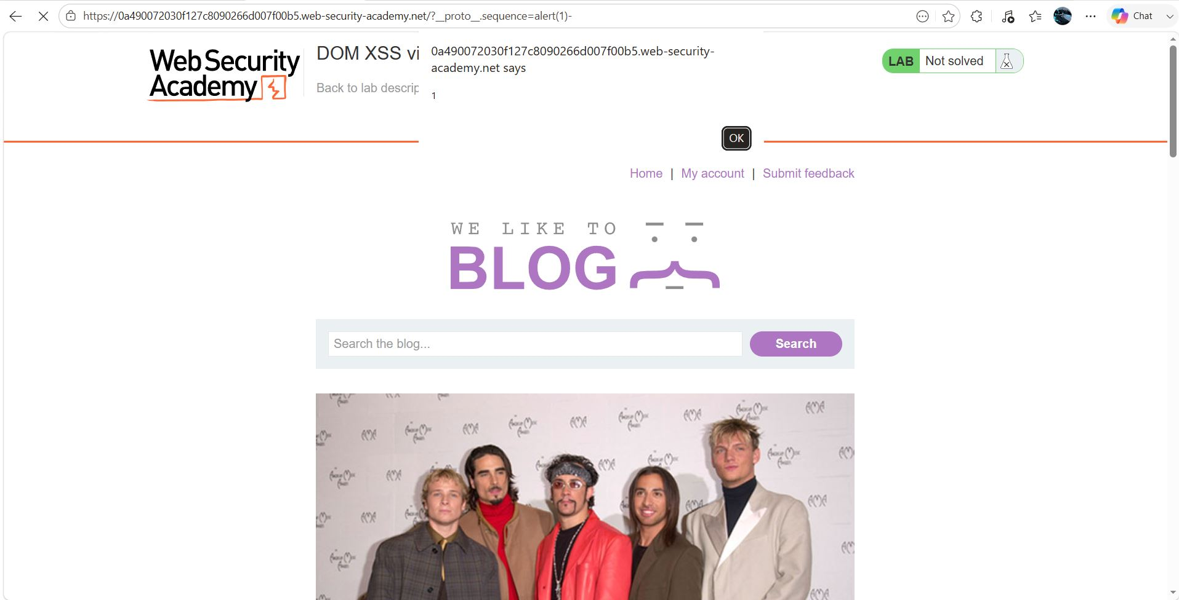
Figure 3: 3
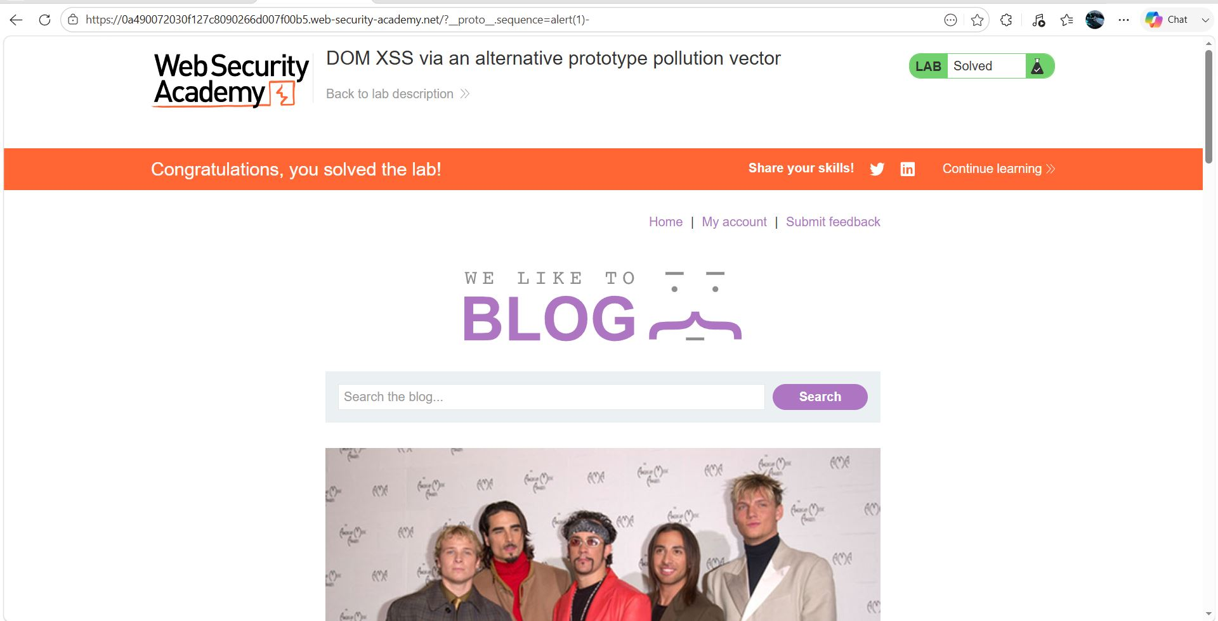
Figure 4: 4

Lab Status: SOLVED

